Que. Write short note on virtual memory management
Virtual memory is a memory management technique used by operating systems to give the appearance of a large, continuous block of memory to applications, even if the physical memory (RAM) is limited and not necessarily allocated in contiguous manner.
Objectives of Virtual Memory
- A program doesn’t need to be fully loaded in memory to run. Only the needed parts are loaded.
- Programs can be bigger than the physical memory available in the system.
- Virtual memory creates the illusion of a large memory, even if the actual memory (RAM) is small.
- It uses both RAM and disk storage to manage memory, loading only parts of programs into RAM as needed.
- This allows the system to run more programs at once and manage memory more efficiently.
# Management of Virtual Memory
Here are 5 key points on how to manage virtual memory:
1. Adjust the Page File Size
- Automatic Management: All contemporary OS including Windows contain the auto-configuration option for the size of the empirical page file. But depending on the size of the RAM, they are set automatically, although the user can manually adjust the page file size if required.
2. Place the Page File on a Fast Drive
SSD Placement: If this is feasible, the page file should be stored in the SSD instead of the HDD as a storage device. It has better read and write times and the virtual memory may prove beneficial in an SSD.
3. Monitor and Optimize Usage
- Performance Monitoring: Employ the software tools used in monitoring the performance of the system in tracking the amounts of virtual memory.
4. Disable Virtual Memory for SSD
Sufficient RAM: If for instance your system has a big physical memory.
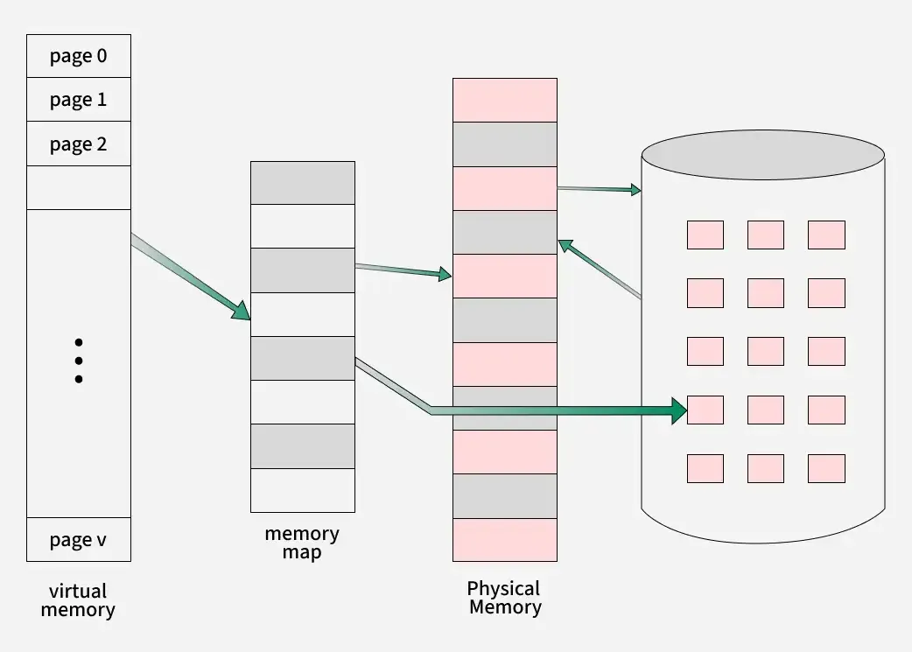
5. Optimize System Settings System Configuration: Change some general properties of the system concerning virtual memory efficiency. This also involves enabling additional control options in Windows.
Que.Elaborate the concept of demand paging with appropriate diagram
Demand paging is a technique used in virtual memory systems where pages enter main memory only when requested or needed by the CPU.
OS loads only the necessary pages of a program into memory at runtime, instead of loading the entire program into memory at the start. Here,
- A page fault occurred when the program needed to access a page that is not currently in memory.
- The operating system then loads the required pages from the disk into memory and updates the page tables accordingly.
- This process is transparent to the running program and it continues to run as if the page had always been in memory.

Working Process of Demand Paging

Let us understand this with the help of an example. Suppose we want to run a process P which have four pages P0, P1, P2 and P3. Currently, in the page table, we have pages P1 and P3.

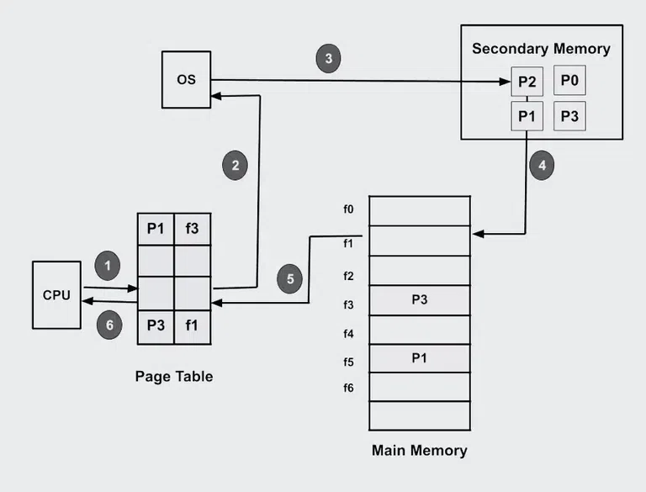
The operating system's demand paging mechanism follows a few steps in its operation:
- Program Execution: Upon launching a program, the operating system allocates a certain amount of memory to the program and establishes a process for it.
- Creating Page Tables: To keep track of which program pages are currently in memory and which are on disk, the operating system makes page tables for each process.
- Handling Page Fault: When a program tries to access a page that isn't in memory at the moment, a page fault happens. In order to determine whether the necessary page is on disk, the operating system pauses the application and consults the page tables.
- Page Fetch: The operating system loads the necessary page into memory by retrieving it from the disk if it is there.
- The page's new location in memory is then reflected in the page table.
- Resuming The Program: The operating system picks up where it left off when the necessary pages are loaded into memory.
- Page Replacement: If there is not enough free memory to hold all the pages a program needs, the operating system may need to replace one or more pages currently in memory with pages currently in memory. on the disk. The page replacement algorithm used by the operating system determines which pages are selected for replacement.
- Page Cleanup: When a process terminates, the operating system frees the memory allocated to the process and cleans up the corresponding entries in the page tables.
Que.Explain Buddy System with the help of neat diagram and example.
The Buddy Allocation System is a memory management technique that divides a large memory block into smaller power-of-two blocks called buddies.
- If a request comes in, the block is repeatedly split until a suitable size is reached.
- When memory is freed, its buddy is checked — if also free, they merge back to form a larger block.
- This makes memory reuse fast and reduces fragmentation.
- Example: A system with 128 KB memory receives a request of 18 KB.
- Solution: Nearest power of 2 ≥ 18 KB = 32 KB.
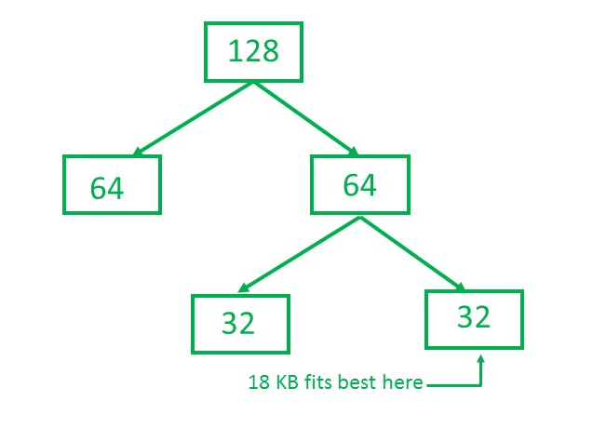
We can see that if we further divide 32 in half it will be 16, which is less than 18 i.e. insufficient to store 18, therefore we can't split the memory further and 32 will become our leaf node.
# Algorithm of Buddy System
Below are the steps involved in the Buddy System Memory Allocation Technique:
- Divide memory into blocks of size power-of-two (2, 4, 8, 16, 32, 64, …).
- Label each block with its size and ID.
- Initially, all blocks are free and maintained in a tree-like structure.
- On a request, find the smallest block that fits. If too large, split until the required size is reached.
- Allocate one block, keep the other free.
- On deallocation, check if the buddy is free → merge to form a larger block.
- Features of Buddy System
- Scalability: Handles large memory efficiently by splitting into smaller blocks and adjusting dynamically.
- Efficient Splitting & Merging: Blocks split into equal buddies when allocated; merged back when both are free.
- Reduced Fragmentation: Merges adjacent free blocks, minimizing wasted gaps.
- Fast Allocation: Quick allocation/deallocation with low overhead.
- Power-of-Two Blocks: Memory divided into 1KB, 2KB, 4KB… simplifies splitting and merging.
Advantages
- Efficient use of memory.
- Fast allocation and deallocation.
- Coalescing reduces fragmentation.

Que.Differentiate
1)Logical and physical address
2)Page table and segment table

1)Logical and physical address

Parameter | LOGICAL ADDRESS | PHYSICAL ADDRESS
Basic | generated by CPU | location in a memory unit
Address Space | Logical Address Space is set of all logical addresses generated by CPU in reference to a program. | Physical Address is set of all physical addresses mapped to the corresponding logical addresses.
Visibility | User can view the logical address of a program. | User can never view physical address of program.
Generation | generated by the CPU | Computed by MMU
Access | The user can use the logical address to access the physical address. | The user can indirectly access physical address but not directly.
Editable | Logical address can be change. | Physical address will not change.
Also called | virtual address. | real address.
2)Page table and segment table
Feature | Paging | Segmentation
Division Unit | Fixed-size pages | Variable-size segments
Managed By | Operating system | Compiler
Unit Size Determined By | Hardware | User/programmer
Address Structure | Page number + page offset | Segment number + segment offset
Data Structure Used | Page table | Segment table
Fragmentation Type | Internal fragmentation | External fragmentation
Speed | Faster | Slower
Programmer Visibility | Invisible to the user | Visible to the user
Sharing | Difficult | Easy
Data Structure Handling | Inefficient | Efficient
Protection | Hard to implement | Easier to apply
Size Constraints | Page = Frame size | No fixed size required
Memory Unit Perspective | Physical unit | Logical unit
System Efficiency | Less efficient | More efficient

